|  |  |  |  |  |  |
| --- | --- | --- | --- | --- | --- |
| **Model Name/Algorithm names** | **Score on training data** | **Score on testing data** | **Accuracy** | **Parameters for Algorithm** | **Best parameter** |
| Multiple Linear Regression | 0.548 | 0.809 | 0.809 | Normalize: [True ,False] |  |
| Ridge Regression model | 0.386 | 0.788 | 0.788 | Alpha:[1e-15,1e-10,1e-8,1e-3,1e-2,1,5,10,20,30,35,40,45,50,55,100] | Alpha=100 |
| Support Vector Regression model | 0.395 | 0.667 | 0.667 | C: [0.1, 1, 10, 100, 1000],  Gamma: [1, 0.1, 0.01, 0.001, 0.0001],  kernel: ['rbf'] | C=10, gamma=0.001 |
| Adaboost Regression Model | 0.94 | 0.81 | 0.807 | n_estimators: [50, 100,150,200,500],  learning_rate : [0.01,0.05,0.1,0.3,1],  loss : ['linear', 'square', 'exponential'] | learning_rate=0.05,  loss='square' |
| Gradient Boosting Regression | 1.00 | 0.85 | 0.854 | n_estimators: [ 100, 200, 300, 400,500, 600, 700, 800, 900, 1000,1100, 1200] min_samples_split: [2,4,8],  learning_rate: [0.01,0.1,1],  max_features: [ 'auto', 'sqrt', 'log2'],  max_depth: [5, 10, 15, 20, 25, 30] | learning_rate=1,  max_depth=15,  max_features='sqrt',  min_samples_split=4,  n_estimators=400 |
| Random Forest Regression Model | 0.595 | 0.535 | 0.591 | n_estimators: [25, 50, 100, 150],  max_features: ['sqrt', 'log2', None],  max_dept': [3, 6, 9,10,15,20],  max_leaf_nodes: [3, 6, 9] | max_depth=6,  max_features='log2',  max_leaf_nodes=3,  n_estimators=25 |

**Model Parameters for tuning and model accuracy:**

**Model Selection Criteria:**

|  |  |  |  |
| --- | --- | --- | --- |
| Name of Model | RMSE | MAE | MEAE(Median Absolute Error) |
| Multiple Linear Regression | 0.1499 | 0.115 | 0.094 |
| Ridge Regression model | 0.1747 | 0.1260 | 0.0869 |
| Support Vector Regression model | 0.1734 | 0.1261 | 0.0995 |
| Adaboost Regression Model | 0.056 | 0.0408 | 0.031 |
| Gradient Boosting Regression | 1.346 | 1.807 | 0.0 |
| Random Forest Regression Model | 0.1483 | 0.1114 | 0.0840 |

GDP prediction for the next five years:

|  |  |  |  |  |  |  |
| --- | --- | --- | --- | --- | --- | --- |
| Year | Linear Model | Ridge Regression | Gradient Boosting Regression | Adaboost | Support vector Regression | Random Forest Regression |
| 2023 | 6.8 | 6.54 | 7.12 | 6.98 | 6.34 | 5.85 |
| 2024 | 5.35 | 4.9 | 5.31 | 5.11 | 5.11 | 5.02 |
| 2025 | 4.37 | 4.35 | 2.87 | 4.35 | 4.22 | 4.06 |
| 2026 | 4.53 | 5.30 | 5.18 | 5.17 | 5.68 | 5.06 |
| 2027 | 5.34 | 4.98 | 5.36 | 5.00 | 5.23 | 5.93 |

Correlation coefficient Matrix showing by Heat map:

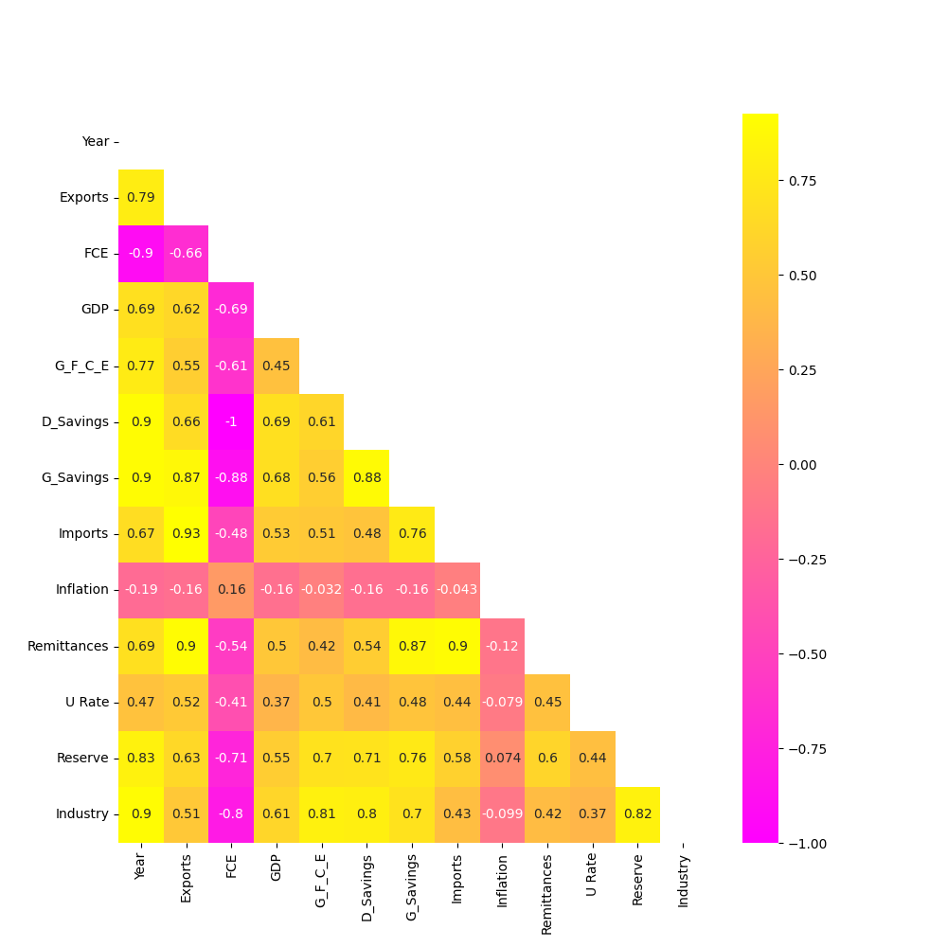

Headmap:

